 |  | 

Reasoning about Fractions – Taster Lesson
Many people find fractions confusing. There are many reasons why fractions seem daunting, but they all boil down to one simple idea: when we write natural numbers and fractions, we use the same squiggles but with different meanings. Natural numbers are counting numbers and are based on addition: as we count a group of objects, we add each object to the group of already counted objects. Each numerical sign, for example 1, 2, 3, 4, indicates a quantity measured by adding the units. Fractions are ratio numbers and are based on division: each fraction, for example, 1/3, 2/6, 3/9, is a number that indicates a quantity measured by a division. These numbers can be read as “one third”, “two sixths”, “three ninths” or as “one divided by three”, “two divided by six” and “three divided by nine”.
When we think about fractions, we need to think about what sort of division we are talking about. The two problems below involve comparing the same fractions, but one problem was much more difficult than the other for children in Year 4.

Problem A Problem B
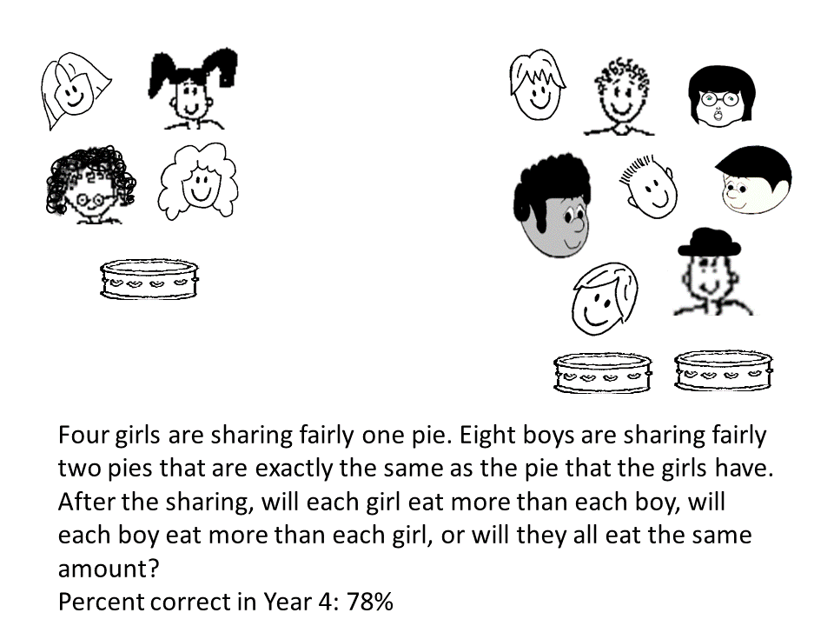
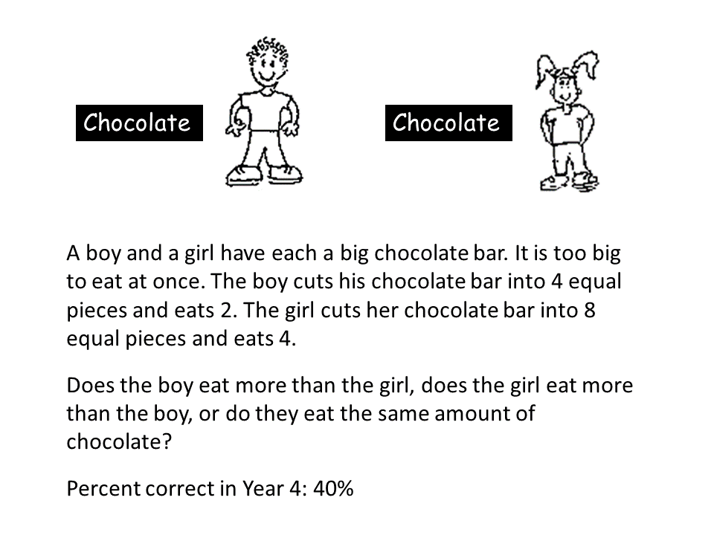

Both problems are comparing 2/4 and 4/8.
Problem A is a typical part-whole problem: the focus in on the number of parts into which the chocolate was cut and the number of parts that each child ate. However, some children focus only on the number of parts that each one ate, 2 compared to 4 parts, and conclude that the girl ate more chocolate. Other children focus on the size of the parts: if the girl cut her chocolate into more parts, each part would be smaller, which leads the children to conclude that the girl ate less chocolate.
Problem B is a typical ratio problem: how many pies per children. When the Year 4 children solved the ratio problem, many were able to recognise that, when the boys shared their pie, they would have 1 pie to share among 4 boys, just like the girls, and concluded that the boys and girls would eat the same amount of pie.
The fact that Year 4 children find ratio problems easier than part-whole problems surprises many teachers because the curriculum suggests that part-whole problems should be introduced before ratio problems. But this is a result that has been replicated in many studies and even in different countries.
Our fractions programme aims to introduce fractions in ratio situations, in which the numerator of the fraction represents the number of items being shared and the denominator represents the number of recipients. Here is the first lesson of the programme for you to try out with your class of Year 4 children. Please, read the instructions and try to stay close to the script so that you maintain the aims of the lesson unchanged.
The aim of the lesson is to promote reasoning about the relation between number of items being shared (chocolates, pizzas) and number of recipients (children). The teacher presents the questions using the PowerPoint slides provided. When giving feedback on the children’s answers, the teacher uses manipulatives to prompt the children to imagine the situation: for example, circles for the children and blocks for the biscuits or pizzas.
After each question, each child writes an answer. The children then discuss their answers in small groups and write down an agreed answer. The teacher calls on one or more groups to present their answers and explain them. If the children seem to get stuck, the teacher asks the children to demonstrate how they got to the answer by using drawings or different objects to represent the children and the biscuits (e.g., circular tokens for the children and blocks for the biscuits).
If the children have gone down an incorrect reasoning path, the teacher uses manipulatives to bring them back to thinking about how many items (chocolates, pizzas) are being shared among how many children. The teacher uses correspondences between items being shared and children to demonstrate the reasoning and asks the children to say what the answer is.
Please, download the PowerPoint slide to present the activities. When you use the PowerPoint in class, you need to use “slide show mode” for the animations to work. Make sure to look at the PowerPoint before you start to use the activities in the classroom.
Only the first slide for each activity is inserted in the text that describes the activity. Print all the pages with the activities so you can use them in the classroom.
THE Lesson has three activities. If you think you cannot finish all the activities in one lesson, stop at the end of activity 2 and start the next lesson from the last two slides of activity 2 as a reminder.

Activity 1

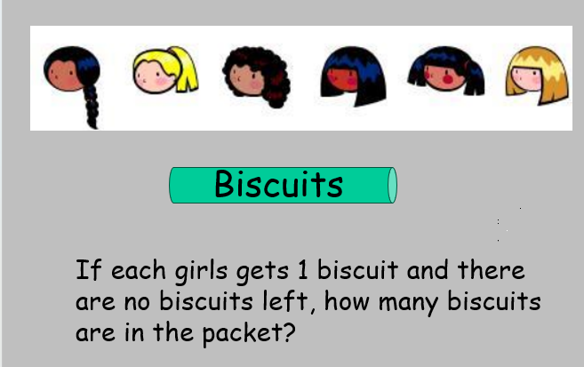 | Six girls are going to share a packet of biscuits. The packet is closed; we don’t know how many biscuits are in the packet.

Questions for the children are in bold and prompts for the teacher are in italics
- If each girl received one biscuit and there were no biscuits left, how many biscuits were in the packet?
If there is a one-to-one correspondence between children and biscuits, the number of children is the same as the number of biscuits. You can support the children in arriving at this conclusion by using objects. Take a circular token to represent the first child and a block to represent a biscuit. Ask the children to think: if they have 6 children, how many biscuits will there be? Continue pairing circles and blocks and ask the children what do they think the number of biscuits is?

- If each girl received a half biscuit and there were no biscuits left, how many biscuits were in the packet?
If each child gets half biscuit, how many children are sharing a biscuit?
If two girls have to share one biscuit, the number of biscuits is half the number of children. If two girls have to share one biscuit, the number of children is twice the number of biscuits.
- If some more girls join the group, what will happen when the biscuits are shared? Does each girl now receive more or less than they did when there were only six girls?
If the number of biscuits is the same, the more children sharing, the less each one gets. This is the inverse relation between the divisor and the quotient.
If the girls have shared out the biscuits and some more girls come, what do they have to do to give something to the girls who just arrived?

Activity 2
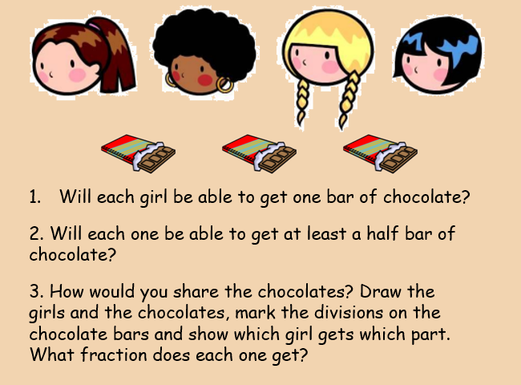 | Four children will be sharing 3 bars of chocolate fairly.  Questions for the children are in bold and prompts for the teacher are in italics  - Will each one be able to get one bar of chocolate? No, more children than chocolates.  - Will each one be able to get at least a half bar of chocolate? Yes, you can cut each chocolate in two equal parts and then you have 6 halves.
3. How would you share the chocolate? Mark the divisions on the chocolate bars. Write what fraction each one gets.
The parts can be approximately the same size, do not have to be exactly the same. The focus is on the correspondences, i.e., which parts are given to whom. Most children will know how to write ½ and ¼ and many will know that 2/4 of the chocolate is the same amount as 1/2 chocolate.
Prompts
The children may write ¼ ¼ ¼ and we then ask them to write the total: How many quarters?
Or they may write: ½ ¼ and we ask them to compare the two solutions – ¾ and ½ plus ¼ - Was it shared fairly either way? Do the children have the same amount of chocolate if you have ¾ or ½ plus ¼? Get the children to discuss this and say why.

Follow-on Activity - Writing Fractions beyond half and quarter
Writing Fractions will help the children think of fractions as one quantity divided by another
- Ask the children how they write a half and a quarter. Have a child show the answer.

Then ask:
How does this number (the number 1 in the fraction ½) show the amount of chocolate? How does his number show how many people were sharing the chocolate? What does this slash / mean? How much chocolate does each one have?
Ask the same questions about ¼.

- Say to the children: Now we have 3 chocolates shared by 4 people. What number will we use to write this division? 3 divided by 4. How much does each one get? Three quarters.

- Then ask them to imagine you had one bar of chocolate to share between three children. What fraction of the chocolate would they receive each? Ask them to write the answer and discuss why it is a 1 on top and a 3 in the bottom. Ask them what does the slash mean. It is good to reinforce that it is not a slash, it is a sign for division.

- Ask if you have one bar of chocolate to share among 5 children, what fraction would each one get? Ask why you use a 1 above the slash. Ask why you use a five in the bottom of the fraction. Remind them: we can say one fifth or we can say one divided by five.

- What about 2 chocolates shared among 5 children? It may seem like repetition but asking the questions about what each number shows gives you the opportunity to call on different children. It also gives the children the opportunity to generalise the rule: the number of things being shared goes on top, the number of things being shared goes under the slash that means division.

- What about 5 chocolates shared among 5 children? How do you write this? What does this number mean? Prompt: 5 divided by 5 means that each child gets what?

Activity 3
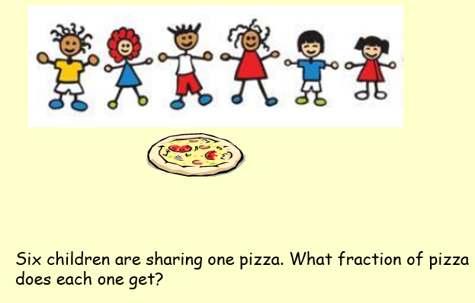 | To link with activity 2, ask if you have one pizza shared among 6 children, what fraction would each one get? Ask why you use a one on top. Ask why you use a six in the bottom of the fraction.  What are two different ways to say this number? Prompt: one sixth or one divided by six.

When they went to the pizzeria, the children ordered 2 pizzas.
Questions for the children are in bold and prompts for the teacher are in italics
- Six children went to a pizzeria and ordered 2 pizzas to share between them. The waiter brought one pizza first and said they could start on it because it would take time for the next one to come. How should they share it?

How much will each one get from the first pizza that the waiter brings? Write your answer.
How much will each one get when from the second pizza when it comes? Write your answer.
How many sixths will each one get?
When you add one sixth to one sixth, what is the total?
The teacher writes 1/6 and a plus sign and then 1/6 and an equal sign and asks: what is the answer? How many sixths? How do we write this? What does the number 2/6 mean?
2. If the two pizzas came at the same time, could they share it differently? How much would each one get?
If the children don’t come up spontaneously with the idea of sharing one pizza among three children, the teacher can suggest this possibility and ask whether the sharing would still be fair. Then ask which fraction of a pizza would each one get.

3. Does each child one get the same amount to eat either way? Why?
Extended discussion highlighting that 1/3 = 2/6 by thinking about the different ways that the pizzas can be shared.

POINTS FOR reflection about the lesson:
- Do you think you achieved the aim of helping the children to make connections between sharing, division, fractions and ratios?
- Did the children focus on the division indicated by the fraction? – 1/3 means one divided by three and means one third, it is all the same thing.
- Did the children think of the slash as a division sign?
- Did they use language flexibly by talking about the numbers in different ways?

