**Introduction to Mathematical Reasoning in Year 2**

This programme was developed for whole class teaching and includes activities to promote both **number sense,** which is essential for learning arithmeticand **quantitative reasoning,** which is essential for problem solving. These two abilities are related but they need to be taught differently.

**The Number Sense Activities** focus on two key ideas: (1) additive composition and place value representation and (2) the inverse relation between addition and subtraction.

1. Additive Composition and Place Value

Additive composition refers to the fact that any number can be thought of as the sum of two other numbers. This means that children should not think of numbers simply as words in a sequence, like words in a poem, but should learn to think of the relations that exist between them. Children cannot really understand what five is unless they also know that it is the same as 4+1 or 3+2 or 6-1.

These activities start with the caterpillar game, in which children are asked to count on from a number on the board. Counting on is a basic skill for learning about additive composition.

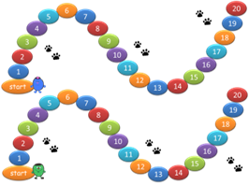

Click here to see the game being used in the classroom [The Caterpillar Game - Teacher Led Class Game - Counting On - YouTube](https://www.youtube.com/watch?v=Qqz_vg_xr-g&t=12s)

|  |  |  |  |  |  |
| --- | --- | --- | --- | --- | --- |
| In this activity, the children are told that they need to fill the spots with 2p coins. They see a list of coins on a page, some 1p and some 2p, and must say how many spots they can fill by exchanging two 1p coins for one 2p coin.  A cartoon of a ladybug  Description automatically generated with medium confidence | How much money do you have? Change the money into 10p and 1p coins and fill in the table.     |  |  | | --- | --- | | tens | ones | |  |  |   A coin with a picture on it  Description automatically generated with low confidenceA coin with a lion on it  Description automatically generated with low confidence  A coin with a picture of a person on it  Description automatically generated with low confidence |

Additive Composition is at the heart of understanding any number system with a base and of representing numbers in writing using the place-value system: 127, for example, means 100+20+7. Research (Nunes & Bryant, 1996) has shown that many children who can count out, for example, 17p using 1p coins cannot count out 17p using one 10p and seven 1p coins. These children have learned to count but have not grasped additive composition. The activities that promote understanding of additive composition involve **equivalence** and **decomposition.**

Here, the children learn about **equivalence** in action as they exchange two 1p coins for one 2p coin. After learning to compose the same value in different ways, children learn to **decompose** values only in tens and ones. This prepares them to write numbers using place value.

1. The inverse relation between addition and subtraction

This is a topic that deserves special attention because it connects both to number understanding and to quantitative reasoning. On the whole, pre-school children understand that if you add, for example, blocks to a row of blocks, you will have more. They also understand that if you take away some blocks from a row of blocks, you will have fewer. But many do not understand that if you add and take away the same number of blocks, you have just as many as you had before. In other words, they do not understand well the idea that a number remains the same if these two transformations cancel each other out.

The teaching activities designed to promote children's thinking about this inverse relation start with a demonstration that is often quite clear to them: we show them a row of blocks of one colour - for example, red - and let them count the blocks. We then cover the middle of the row so that they can no longer count the blocks. Then we add blocks of a different colour - say, black - to the row and take away the same black blocks. We ask them to say, without counting, how many blocks are now in the row. Because the blocks are of a different colour, it is obvious to the children that the red row has not changed. This easy start gives them a grounding for reasoning about how the number of blocks changes: when we add 5 black blocks and take 4 away, they see that 1 was left in the row. When we add 2 and take away 3, they see that we took 1 red away. Through a carefully planned series of manoeuvres illustrated below, we help them think about the inverse relation between addition and subtraction, and they make good progress both in understanding more about numbers and about quantitative reasoning.

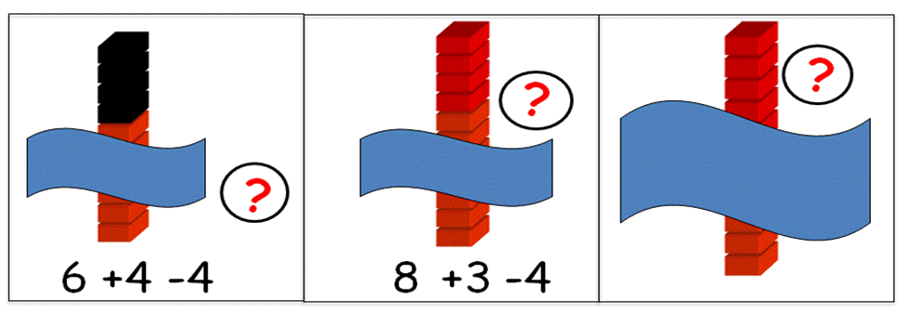

In the easier items of the games about the inverse relation between addition and subtraction, the information is made salient by the use of colours; the numbers are all visible when the question is posed. In the more difficult items, the blocks are all of the same colour and the information is less salient. In later items, the information has to be recalled; it appears on the screen and then disappears before the question comes up.

Click here to see some inverse relation activities [The inverse relation - YouTube](https://www.youtube.com/watch?v=9sRTAalbJT8)

**The Quantitative Reasoning Activities** focus on two key ideas: (1) part-whole or additive reasoning (which includes addition and subtraction) and (2) one-to-many correspondence or multiplicative reasoning (which includes multiplication and division).

1. Part-Whole and Additive Reasoning

Part-whole relations form the core of reasoning about addition and subtraction: in short, additive reasoning.   When children master the logic of part-whole relations, they can solve many problems that are difficult to start with.

Most Year 2 children will find this problem easy:

Holly had 5 books; Granny gave her 3 books; how many does she have now?

However, many will find this problem difficult:

Holly had some books; Granny gave her 3 books; now she has 8; how many did she have before?

Clearly, both problems involve reasoning about part-whole relations. In both, the number of books now is the sum of the two parts - the number of books that Holly had and the number that Granny gave her. But the second problem involves some transformation of the information before calculation, i.e. the children know how many books Holly got from Granny and the total, but need to think of what the situation was like **before**she got the books from Granny. This is another use of reasoning about the inverse relation between addition and subtraction: before Holly got 3 books from Granny, she had 3 books less. Our additive reasoning activities are designed to encourage children to think of part-whole relations and the operations of addition and subtraction from different perspectives.

1. **One-to-Many Correspondence and Multiplicative Reasoning**

Like additive reasoning, multiplicative reasoning is necessary for understanding relations between numbers and written numerical representation. When we write the number 25, the digit 2 represents 10x2. When we encourage children to think more about one-to-many correspondence, which they understand quite well, they can also make progress in understanding numbers written using a place-value system. Multiplicative reasoning is also the basis for the development of quantitative reasoning skills of great significance in problem solving throughout primary school: for example, proportions problems.

Many people are surprised to find that even children in Year 1 can successfully solve multiplication and division problems when they are offered the right sort of support. Look at the problem below, which also shows how one child got to the answer. The reasoning is perfect, and we should encourage children to develop it further.

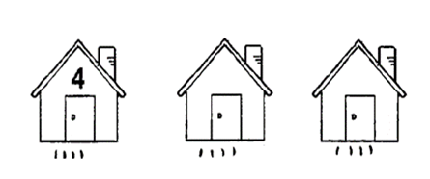

*Four rabbits live in each of the 3 houses, how many carrots do we need to give one carrot to each rabbit?*

Teachers won't be surprised that Year 2 children can solve the problem below. Both problems are solved by establishing one-to-many correspondence between two quantities and Year 2 children can do this when they have the right support—i.e., when they have manipulatives to represent both quantities, e.g. rabbits and biscuits.

*How many biscuits will each rabbit receive if we share the biscuits fairly?*

**The programme**

The programme is organised in 12 units to be taught once a week in the time scheduled for mathematics teaching; no extra time is needed. Each lesson starts with a whole class introduction to the concept. The teacher uses a PowerPoint presentation, often with the support of manipulatives, to explain the concept. The children are active all the time, answering questions, explaining how they arrived at their answers and recording in their workbooks. They are encouraged to use actions and manipulatives to explain their reasoning.

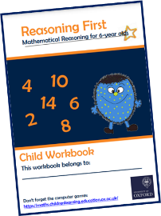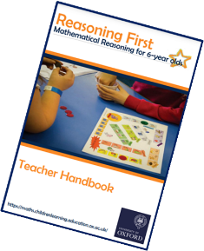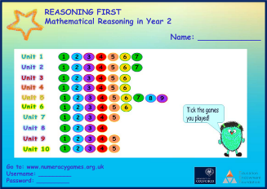

During the second part of the lesson, the children are divided into two groups. Some children, supervised by the TA play computer games that give them further practice with the concept. The others work with the teacher to do further work, extend the concept or for pre-teaching of the next concept.

The Mathematical Reasoning in Year 2 programme was assessed in a randomised control trial funded by the Education Endowment Foundation (EEF) in a project that involved 55 schools and 2087 children. The external evaluators found that the children who participated in the programme made an extra three months of progress in mathematics than those who did not participate. [Mathematical_Reasoning.pdf (educationendowmentfoundation.org.uk)](https://educationendowmentfoundation.org.uk/public/files/Projects/Evaluation_Reports/Mathematical_Reasoning.pdf)

For more information about the programme and the on-line PD please visit our website at <https://reasoningfirst.studiorepublic.com/>