|  |  |  |
| --- | --- | --- |
|  |  |  |

**Mathematical Reasoning – Taster Lesson on Inversion**

Many children understand that if you add, for example, blocks to a row of blocks, you will have more. They also understand that if you take away some blocks from a row of blocks, you will have fewer. But many do not understand that if you add and take away the same number of blocks, you have just as many as you had before. In other words, they do not understand well the idea that a number remains the same if these two transformations cancel each other out. The aim of the inversion activities is to help children to make this connection between the inverse relation between addition and subtraction and number invariance.

**Activity 1** Teacher Demonstration with Blocks

You will need:

* two sets of blocks, 8 of one colour, 8 of a different colour.
* a cloth to cover the blocks.

The aim of this activity is to develop children’s reasoning skills about the inverse relation between addition and subtraction **without calculating**.

Instructions for demonstration

* The teacher makes one column of blocks of the same colour (e.g., 6 blocks).
* One child counts the blocks, and the teacher then covers part of the column with the cloth, leaving both ends exposed. This is to prevent the children counting the blocks.
* The teacher then asks the children to look closely and adds a column of blocks of a different colour (e.g. 5) and says "I am adding 5 blocks and taking away 5 blocks" (the teacher takes away the same 5 blocks).
* The teacher then asks: how many blocks are under the cloth now?

This demonstration is repeated three times. The number of blocks at the start is changed. The teacher sometimes adds and takes away the same number and at other times adds a number of blocks and takes away one less (e.g., adds 4 and takes away 3).

**Key Questions to ask**

* How many blocks did we start with?
* How many did we add?
* How many did we take away?
* Did we add more or take away more? How many more? So how many do we have now?

The children should consider all the information before working out the answer. **If they start to calculate** you can say: Look at what we have now. Did I leave an extra block? So how many blocks are there now? Did I leave an extra block? So how many blocks are there now?

**Activity 2** Teacher led activity using a PowerPoint.

The teacher puts up the inversion questions on the screen one at a time explaining that the children must watch carefully as the picture on screen shows the number of blocks at the start, how many were added and how many were taken away. The children write down the number of blocks at the end. After the children have completed the question, the teacher asks a child to answer and explain why he/she thinks so. The teacher then shows the answer by clicking on to the next screen. The screen shows the number of blocks at the beginning, the number added, and the number taken away.

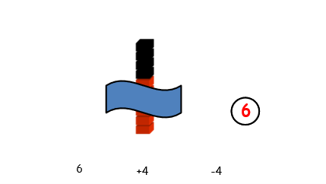There are six blocks, and I am using a cloth to cover the column of blocks. Now I am adding four blocks to the column. I take four blocks from the column. How many blocks are there now?

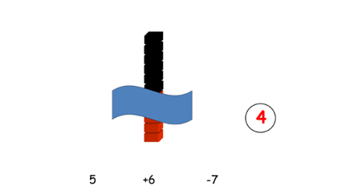Repeat the same instruction (with different numbers) for the rest of the slides.

Before the answer is shown on the screen, a child is asked to give the answer and explain why he/she thinks their answer is correct.

**Children should be encouraged to think about the relation between the number going in and the number coming out and the effect that has on the original number rather than doing an addition and then a subtraction sum.**

**Key Points**

* Ask the children to explain their strategy, whether they answered correctly or not.
* Refer to the use of inverse relation in your feedback – “Well done, you spotted that we added one more than we took away.”
* If the child carried out an addition and then a subtraction, you can ask them to look at the numbers and see if there is a faster way of coming up with the answer. Encourage the child to think about what happens if you take away one more that you add, for example.
* Always attempt to attribute success to the specific strategy required – *“You are starting to be more efficient now that you are using the inverse.”*

**Activity 3** Teacher Demonstration with Counters

You will need: A small box or bag, and 20 counters.

The aim of this activity is to encourage the children to start thinking about the relations between quantities without knowing the exact quantities. This helps them to generalise their reasoning about the inverse relation, which is a significant development.

Instructions for demonstration

* The teacher shakes the bag to indicate that there are counters inside but says she doesn't know how many.
* The teacher asks a child to put some counters in; she then takes the same number out.
* She then asks the children whether there are now more, or less, or the same number of counters in the bag.
* The child who gives the answer is also asked to explain why. If the children ask how many are in the bag, the teacher should emphasise that she doesn't know.

This demonstration can be repeated 8-10 times so that the children get used to thinking about the relations between the quantities without knowing the quantities. During these demonstrations, the teacher sometimes takes out the same number of items that the child put in, sometimes takes out one more item than the child put in, and sometimes takes out one less item than the child put into the bag. A different child is asked to come to the front to answer the question. Each time the teacher asks the other children whether the answer is correct and why.

**Key Questions to ask**

* Did I leave extra ones, or did I take out extra ones?
* How does that affect the original number?
* Is it more than before, less than before or the same as before?

**Key Points**

* Ask the children to explain their strategy whether they answered correctly or not.
* Refer to the use of the inverse relation in your feedback – “*Well done, you spotted that we added more than we took away.”*
* Always attempt to attribute success to the specific strategy required – “*You are starting to reason whether there will be more, less or the same.”*
* *When you use your own numbers, keep the difference between the number added and subtracted to 1. This allows the child to focus on the inverse relation between addition and subtraction and not spend effort in thinking about the numbers themselves.*